3.2 Flights Data Analysis
3.2.1. Missing data, zeros and duplicates
The data understanding phase started with a thorough data quality assessment. Although no missing values were found, 2,903 duplicates were identified and removed to ensure dataset integrity. We then examined the occurrence of zero values across variables, noting that some features contained over 90% zeros and NumFlights, a key feature, around 50%. Importantly, we do recognize that zeros are meaningfully represent customers with no flights during certain periods.
3.2.2. Data agregation and inconsistencies
Nonetheless, given the sparsity of the monthly dataset, we aggregated the data to an annual level to improve data density and interpretability, ensuring a row per costumer. However, to retain insights about seasonal behavior, we created quarterly aggregate variables for the following four metrics: NumFlights, NumFlightsWithCompanions, DistanceKM and DollarCostPointsRedeemed.
This decision was based on the perfect correlations observed between DistanceKM and PointsAccumulated and between DollarCostPointsRedeemed and PointsRedeemed, implying minimal information loss from the dimensionality reduction.
3.2.3. Data Visualization
We explored variable distributions using histograms and boxplots, both including and excluding zero values, to obtain a comprehensive perspective. Outlier detection showed minimal presence, with a maximum of 1.48% in DollarCostPointsRedeemed, so all data points were retained. Finally, we analyzed pairwise correlations using both Pearson and Spearman coefficients (as all variables are numerical). Besides the perfect correlations mentioned above, we identified a strong relationship between DistanceKM and NumFlights (plausible) and consequently between PointsAccumulated and NumFlights – a logical outcome, since the first is derived as a percentage of flight distance.
3.2.4. Exploratory Analysis of Behavioral and Seasonal Patterns
Divided by seasonal and non-seasonal analysis, we performed a comprehensive analysis to understand the relationships between key behavioral variables and their implications for clustering, such as

3.2.4.1. Non-Seasonal Analysis

We performed a comprehensive analysis to understand the relationships between key behavioral variables and their implications for clustering, such as:
- Pairwise Relationship of All Original Variables;
- Average Points Redeemed by Distance Range;
- PointsAccumulated by Flight Segment.

3.2.4.2. Seasonal Analysis

We also analyzed quarterly and monthly variations to capture seasonal travel and redemption behaviors that may inform future customer segmentation, such as:
- Average Distance per Flight by Quarter;
- Quarterly Seasonality Index;
- Average DollarCostPointsRedeemed per Flight by Quarter;
- Average Number of Flights per Month by Quarter.

4.2. Flights Data: From Insights to Features
Building on the exploratory findings, we conducted a deeper investigation into variable behaviors to guide subsequent feature engineering and clustering preparation.

4.2.1. Non-Seasonal Patterns
We discovored that customers tend to redeem points on shorter flights. This insight was reinforced by a frequency analysis of redeemed points across flight distance intervals, which revealed that the majority of points are redeemed on flights between 1,000 and 3,000 km. This behavioral pattern may later inform the formation of customer clusters, distinguishing short vs long-haul preferences or even a campaing to attract long-haul costumers to redeem more their points.
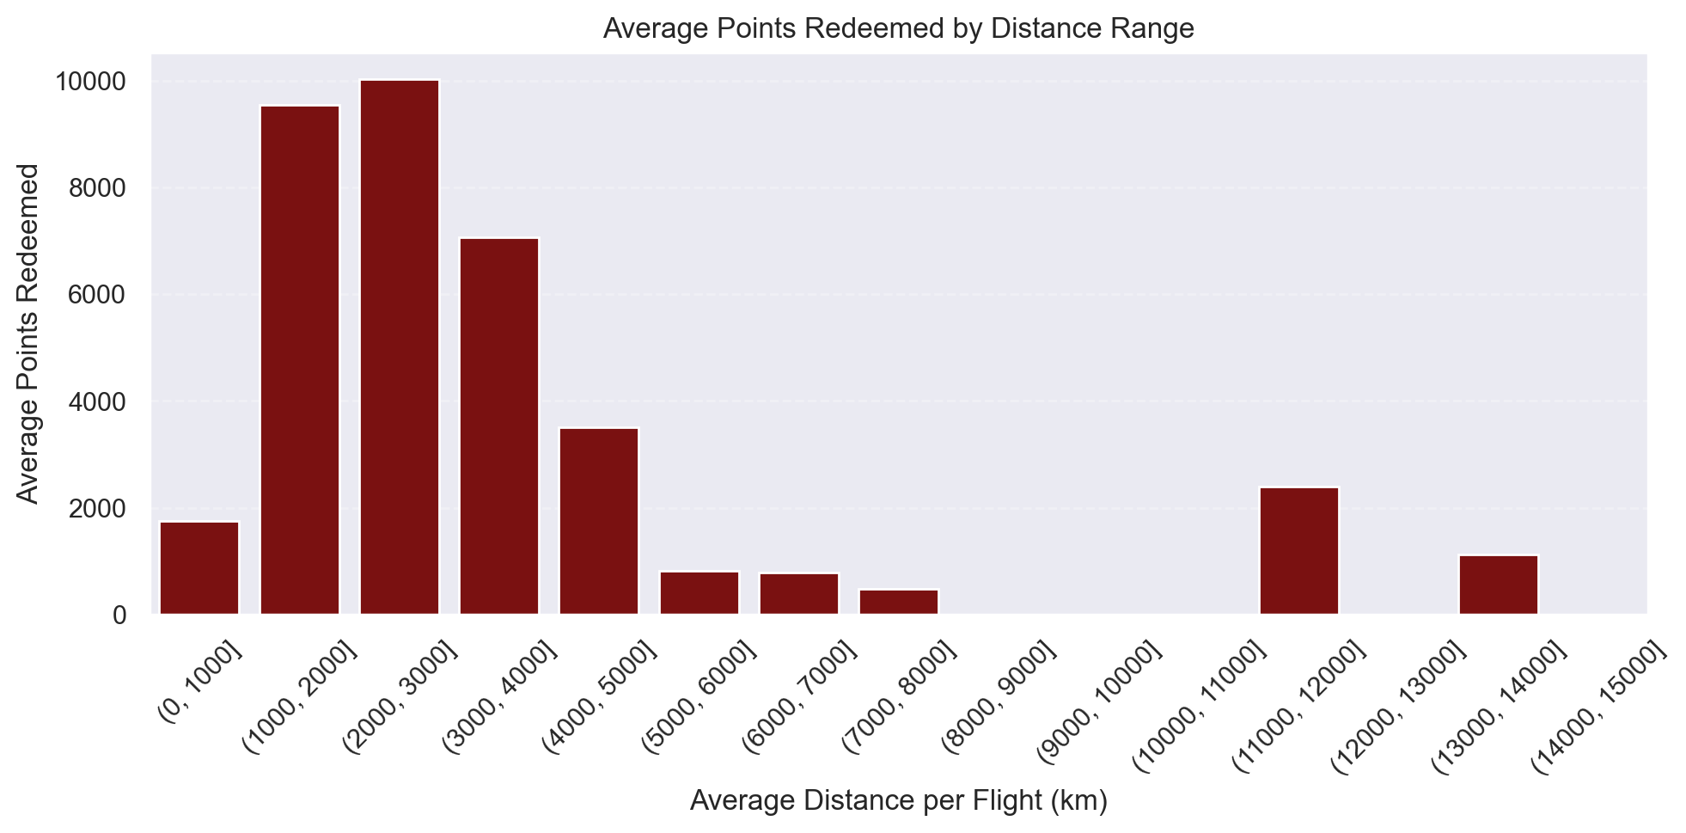
Figure x – Average Points Redeemed by Distance Range

Regardling, costumers frequency of flights, the results showed that less frequent flyers accumulate substantially fewer points, with a more pronounced difference between infrequent and mid-frequency groups than between the two higher segments – suggesting diminishing returns in points accumulation for frequent travelers.

4.2.2. Seasonal Patterns
Our seasonality analysis, confirmed the expected pattern: highest flight activity in Q3 (summer vacation period) and lowest in Q1. Similar seasonal patterns were observed across all four quarterly variables, reinforcing the consistency of these trends.
Curiously, when analyzing the average distance per flight by quarter, we found that flights in Q3 tend to be shorter, while those in Q1 are longer. Similarly, customers redeem more total points in Q3 (consistent with higher travel volume), but redeem fewer points per flight, reinforcing the observation that redemptions are concentrated in shorter trips.
Finally, with the monthly analysis we could identify within-quarter variations, specially the impact of December within Q4. The distribution of flights per month highlighted that June, July, August, and December are peak travel months (corresponding with major holiday periods), while average flight distance remains relatively stable across months, less so in June when flights are shorter.
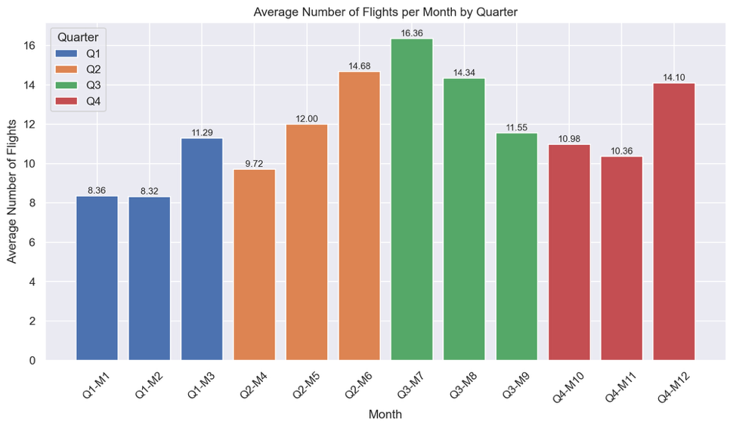

Figure x – Average Number of Flights per Month by Quarter
4.2.3. Feature Strategy and Clustering Preparation
These findings directly informed our feature strategy and give usefull insights to prepare for a deep clustering anylisis. Lastly, the introduction of a new variable, Top3Months, which identifies each customer’s three most active travel months, adds an interpretable behavioral dimension that captures individual travel timing preferences. This engineered feature is particularly promising for future clustering, as it may help differentiate customer groups based on their preferred travel months (summer-oriented vs winter-oriented), potentially revealing patterns relevant for loyalty program strategies or targeted marketing.

